Go, therefore, and make disciples of all nations, baptizing them in the name of the Father, and of the Son, and of the Holy Spirit, teaching them to observe all that I have commanded you. (Go, Make, Baptize, Teach)
Matthew 28:19-20
St. Patrick Parish Mission Statement
We are a community of Catholic Christians who desire to grow closer to the living God. It is seen in the way we…
- build Christ-like relationships with others (Go),
- help people to fall in love with God (Make),
- fall deeper in love with God by entering the life of the church through the Sacraments, especially the Eucharist (Baptize),
- serve and witness inspired by the Holy Spirit (Teach).
We do this because we are children of God who long for all to share in eternal life.

Church & Parish Offices
St. Patrick Parish
12 Main St., Pelham, NH 03076
603-635-3525 (office)
603-635-3919 (fax number)
Website: www.stpatricks-pelham.com

Pastor: Very Rev. Volney J. DeRosia
Email: fathervon@comcast.net
Priest in Residence: Rev. Msgr. Richard Kelley
Faith Life Director: Adam Castor
Email: faithlifeformation@comcast.net
Business Manager: Therese Soucy
Email: therese42852@comcast.net
Secretary: Kathleen Jean
Email: kathy7421@comcast.net
Music Ministry:
Gary Williams 603-635-7669
Stephen Caruso 603-401-0837

St. Patrick Parish
2022-2023
Annual Report

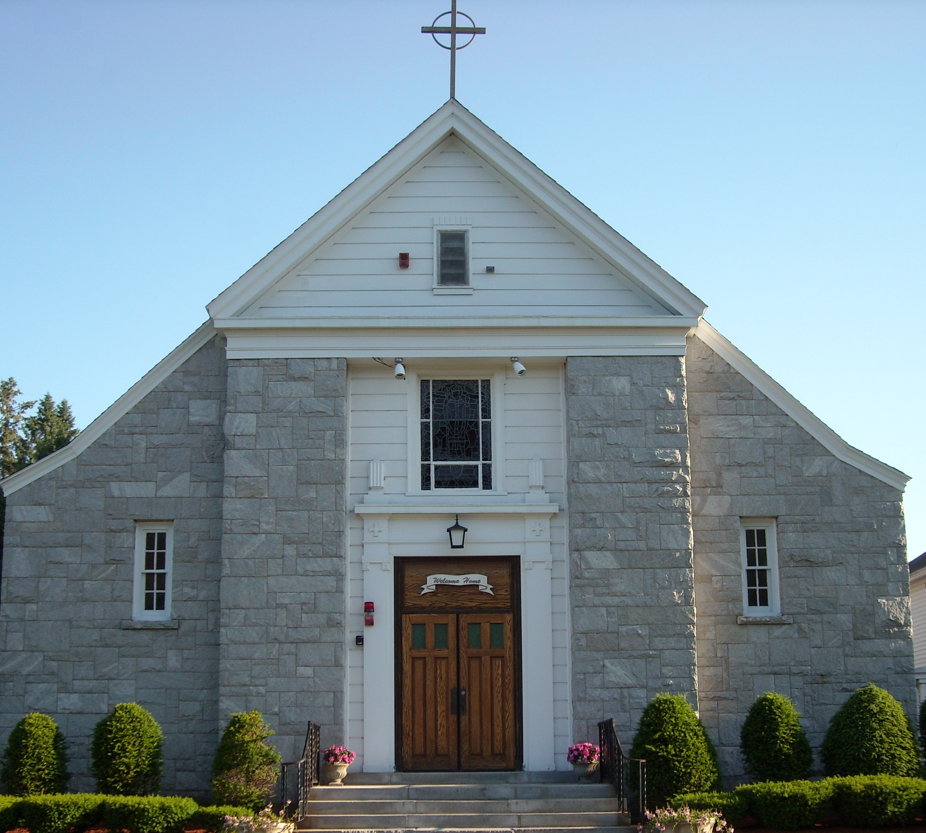

Pelham, NH

Dear brothers and sisters,
As I’ve mentioned before, we are in a National Eucharistic Revival. It is an opportunity for people to connect or reconnect with the Presence of the Lord in the Blessed Sacrament. Through this Revival, we are hoping to cultivate Eucharistic Amazement, and help people in their faith in Jesus’ incredible presence in the Eucharist – not merely as symbol, but Body, Blood, Soul and Divinity in reality, here present. Because the Eucharist is the source and summit of our faith, everything we do, in some way, revolves around the Eucharist.
This past summer, we had a Stellar time at Vacation Bible School. We had over 80 excited kids and 40 teen volunteers, not to mention the many dedicated adult volunteers. In addition to the crafts, games, Adoration of the Blessed Sacrament and Holy Mass, the kids learned about Blessed Carlo Acutis – the first millennial to be raised to the Altars. Blessed Carlo was a video game playing teenager who wanted people to know about the Eucharistic Miracles and fall in love with Jesus. Our kids learned a lot from him!
Over this past year, we had seminarian Phong Le join us to grow in his understanding of the English language, American (and specifically New Hampshire) culture, and to continue discerning his vocation to be a priest in the Diocese of Manchester. His witness of faithfulness, and missionary spirit were greatly appreciated. After a visit home (Vietnam) over the summer, he is back in Seminary in Connecticut, and is on the road to being ordained a priest in June of 2026.
Adoration of Jesus’ True Presence in the Eucharist has continued every day before daily Mass from 6:30-7:40am, and on Wednesdays from 8:30-9:30am, and 2:00-9:00pm. Jesus is the answer to every problem we have: I invite you to spend time with Him. In addition to regular Masses and Confession, we baptized 50 children, 36 people received the outpouring of the Holy Spirit in Confirmation, 24 people made their first Holy Communion, and two men walked through the RCIA process to become Catholic. We have also been having monthly Healing Masses, where God brings His miraculous love to people through the Eucharist and laying on of hands.
I encourage you now, more than ever, not to stop learning about and growing in your faith. In May, we had “Made for More” with Christopher West and Mike Mangione. Our Monday night teachings watched and discussed The Chosen series – and right now, we’re learning about Christ in the Eucharist. Last October, we had our parish retreat – Light of the World – which brought more people together and closer to the Lord. I encourage you to discern whether God is calling you to this retreat October 20-23 this year. We still have our FORMED.org subscription, which has all manner of video and audio teachings, e-books and movies for you and your family. And they’re free for you! You can subscribe by going to pelham.formed.org. Check it out! In the spring, we will be having the Disciples of the Lord Jesus Christ come for a Lenten Mission, March 10-12, 2024 – Mark your calendars!
Since 2017, we have been having the bimonthly Community Dinners, offsetting the months that the Congregational Church has held theirs. Since then, we have given free meals to over 2000 people. More than the food, though, there is a need for fellowship and companionship that draws attendees every other month.
At the end of the fiscal year (June 30), I was happy to see that we ended this year in the black by about $3,800, not including the income for the Building Fund (capital improvements). Looking ahead, I am aware that the Church needs new roofing (working on that currently), new internal painting, new flooring, the pews need to be fixed and repainted, and there are a multitude of other items that need to be looked at. I’m working with the Diocese to see what can be done, and –hopefully – will be approaching the parish about these capital improvements in the near future.
You have been so generous! I can’t thank you enough!!! Thank you for continuing to support St. Patrick Parish and our mission to bring Jesus’ healing love to Pelham and the surrounding community!

Grace and Peace,
Fr. Von

Revenue

Offertory – Envelopes 282,899
Offertory – Electronic Giving 101,935
Utilities 26,883
Holy Days 51,622
Donations 29,167
Flowers & Memorials 6,980
Maintenance – Grounds 12,776
Stole Fees 17,077
Rental Income 3,930
Rebates 10,133
Fund Raising Events 4,636
Other Income 25,873
Faith Life 22,922
Programs 8,866
Diocesan Collections 17,683
Total 623,382

Building Fund 29,161

Grand Total Revenue $652,543

Balance of Funds as of 6/30/2021

Parish Checking Account $70,542
Savings–Capital
Improvement $130,397

Expenditure

Salaries & Benefits 165,604
Insurance 39,648
*Parish Wide –Operating Costs 46,691
Liturgical Expense 27,324
Church – Operating Costs 33,916
Parish Center –
Operating Costs 17,890
School – Operating Costs 33,164
Rectory – Operating Costs 35,846
Parish Office Costs 17,713
Faith Life Program 65,924
Programs 28,335
Fund Raising Expenses 0
Diocesan Assessments 89,803
Diocesan Collections 17,683

Grand Total Expenditure $619,541

Accounts Payable $2,187

*Parish wide operating costs includes: contracted services, maintenance contracts, equipment repairs & purchases and all items for the good of the whole parish.

