Worship | - •  - Spring 2024
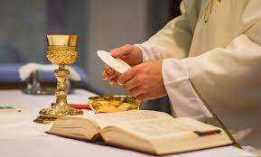  Pray with us as we work to heal our relationship with Jesus Christ, our neighbors, and all of Creation …  God’s Great Gift of Love  Eucharistic Adoration:  Divine Mercy for the Earth  Monday, Earth Day, April 22, 2024, 7:00 pm  Mass for Creation:  Celebrating Laudato Si’ Week  Tuesday, May 28, 7:00 pm | It is in the Eucharist that all that has been created finds its greatest exaltation. LSi’236  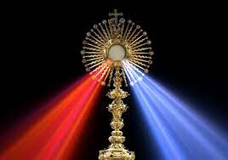  St. Patrick’s Church  12 Main St. Pelham, NH  Rev. Volney DeRosia, officiating  Supported by the Laudato Si’ Circle - a Creation Care Team.  For information contact:  Julia Steed Mawson via the parish office.

