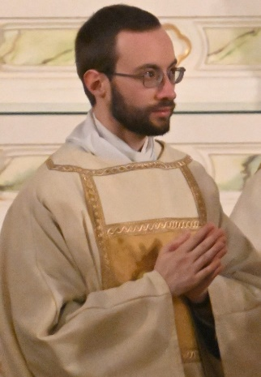
YOU ARE INVITED TO JOIN
REV. MR. ERIC OUELLETTE
AS HE CELEBRATES HIS ORDINATION
TO THE HOLY ORDER OF PRIESTHOOD

ORDINATION
SATURDAY JUNE 1, 2024 AT 10 AM
SAINT JOSEPH CATHEDRAL
145 LOWELL STREET, MANCHESTER

EUCHARISTIC ADORATION WITH CONFESSIONS
SATURDAY JUNE 1, 2024 AT 6:00 PM
OUR LADY OF THE MIRACULOUS MEDAL CHURCH
289 LAFAYETTE RD. HAMPTON
POTLUCK SUPPER TO FOLLOW
PLEASE BRING SOMETHING TO SHARE

FIRST MASS OF THANKSGIVING
SUNDAY JUNE 2, 2024 AT 1:00 PM
SAINT JOSEPH CHURCH
200 PLEASANT STREET, EPPING
RECEPTION TO FOLLOW

ADDRESS QUESTIONS AND RSVP’S TO KAREN OUELLETTE VIA TEXT OR CALL AT 603-770-5827

