To Hope and Act With Creation
Season of Creation Sept. 1 – Oct. 5, 2024
Celebrating Creation … God’s Great Gift of Love
Offered by the Laudato Si’ Circle – a Creation Care Team Ministry at St. Patrick’s Parish, Pelham, NH

Wk. 1 – Sept. 1 – 8: Celebrating the First Fruits of Hope with Creation
Families/Individuals: Put the G (God) in your G(Awed) Walks! On your G(Awed) Walk, pray St. Francis of Assisi’s Canticle of the Creatures. * (see over) Why not visit one of Pelham’s beautiful Conservation Areas? https://tinyurl.com/5n95hjv2 Consider praying the Laudato Si’ Chaplet as you go! https://tinyurl.com/yzru2sm6
Community: Sunday, Sept.1, 2024 9 am ET, Herald the opening of the Season of Creation with this ecumenical Prayer Service for Creation Day https://seasonofcreation.org/event/prayer-service-for-creation-day/

Wk. 2 – Sept. 9 – 15: Renewing Our Vocation as Stewards
Families/Individuals: Read and try, “10 Ways You Can Make a Difference” (see over **)
https://catholicclimatecovenant.org/resources/10-ways-you-can-make-a-difference/
Community: Sat. Sept. 14, Act local! Become a Watershed Warrior! Learn about pond critters, the watersheds they live in and how we can care for them at Pelham’s Old Home Day. Visit the Conservation Commission and Stormwater/Planning Office’s We Love Water and Watersheds! booth for hands-on activities and info and fun!

Wk. 3 – Sept. 16 – 22: Implore God’s Help/Ask His Pardon
Families/Individuals: Participate in confession or your own Ecological Examen. (see over ***)
Community: Saturday, Sept 21, 6:00 pm. Join NH Interfaith Power and Light for a showing of the film Common Ground: Saving the Planet One Acre at a Time at Sweeney Hall, NHTI – Concord’s Community College, 4 Institute Drive, Concord, NH. Free! Register here bit.ly/3WOXr6x or go to nhipl.org/events

Wk. 4 – Sept. 23 – Sept 29: Thank God for His Handiwork
Families/Individuals: Focus your mealtime prayers on thanksgiving for Creation (see over ****)
Community: Sunday, Sept 29, Have fun at the Creation Corner for Kids during St. Pat’s, Parish Picnic Pelham

Wk. 5 – Sept 30 – October 5: Honor the Feast of St. Francis of Assisi
Families/Individuals: Oct 4, Pray the St. Francis of Assisi Novena. Go to https://tinyurl.com/4tdde28c
Community: Oct. 5, 10 am Join St. Patrick’s Laudato Si’ Circle Creation Care Team for a Rosary Walk for Creation offering petitions and gratitude to the Holy Mother Mary for Creation, God’s great gift of love.

Receive Daily Season of Creation Reflections from the Creation Care Ministry of the Paulist Center, Boston.
To sign up go to … seasonofcreationdaily.org

* See back page for prayers and resources *

For Season of Creation information go to seasonofcreation.org
Questions? Contact: Laudato Si’ Circle Volunteers Julia Steed Mawson at islandwork999@gmail.com or Walter Bacigalupo at walterpat@me.com

* Wk. 1 – What’s an “Awe Walk”? It is an intentional way of walking/meditating …
* Wk. 1. What’s a G(awed) Walk? “… a walk within a place of meaning & beauty, where your sole (soul!) task is to encounter something that amazes and transcends, be it big or small.” https://ggia.berkeley.edu/practice/awe_walk

** Wk. 2. Ten Ways to Make a Difference
1. Be energy efficient.
2. Calculate your carbon footprint. Try the EPA carbon footprint calculator
3. Adjust the thermostat.
4. Adjust your driving routine. Combine multiple errands into one trip.
5. Go meatless on Fridays. Livestock produces about 4% of US greenhouse gas
6. Reduce, Reuse, Recycle
7. Avoid single use plastics – use your own travel mug/cup and reusable shopping bags
8. Use less water.
9. Petition policy makers to take action on climate change.
10. Join St. Patrick’s Laudato Si’ Circle -
A Creation Care Team Ministry Contact Walter Bacigalupo walterpat@me.com or Julia Steed Mawson islandwork999@gmail.com
Adapted from Catholic Climate Covenant https://catholicclimatecovenant.org/resource/10-ways-you-can-make-difference

*
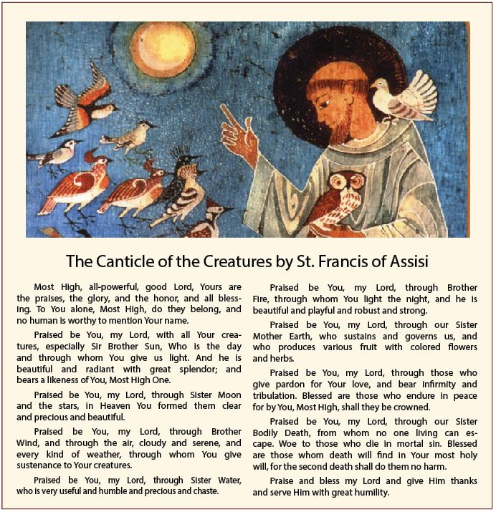

*** Wk. 3 – An Ignatian Ecological Examen:
1. I give thanks to God for creation and for being wonderfully made.
Where did I feel God’s presence in creation today?
2. I ask for the grace to see creation as God does – in all its splendor and suffering.
Do I see the beauty of creation and hear the cries of the earth and the poor?
3. I ask for the grace to look closely to see how my life choices impact creation, the poor and vulnerable. What challenges or joys do I experience as I recall my care for creation? How can I turn away from a throwaway culture and instead stand in solidarity with creation and the poor?
4. I ask for the grace of conversion towards ecological justice and reconciliation.
Where have I fallen short in caring for creation and my brothers and sisters? How do I ask for a conversion of heart?
5. I ask for the grace to reconcile my relationship with God, creation, and humanity, and to stand in solidarity through my actions. How can I repair my relationship with creation and make choices consistent with my desire for reconciliation with creation?
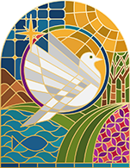
6. I offer a closing prayer for the earth and the vulnerable in our society.
http://www.ecologicalexamen.org

**** Wk. 4 – Mealtime Prayer of Gratitude for Creation
Earth maker and Lord of all creation,
we are mindful that this food before us
has already been blessed by your sun, soil, water, and air.
We pause to be grateful for these hidden treasures of life in this food.
For this food and all of creation, your great gift of love, we thank you Lord.
(Excerpted and adapted from Food as A symbol by Edward Hays).

