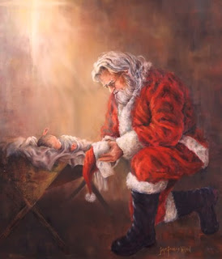

St. Patrick’s Christmas
Craft Fair

St. Patrick Parish Center
12 Main St., Pelham, NH 03076

Dec. 4th - 9am to 4pm

- Local Crafters
- Scrumptious Food
- Bake Table with Sweet Surprises
- Door prize & raffle

